5.38: a) There is no net force in the vertical direction, so 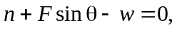 or 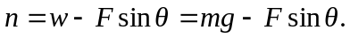 The friction force is 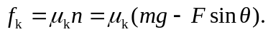 The net horizontal force is , and so at constant speed,
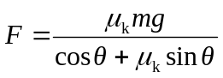
b) Using the given values,
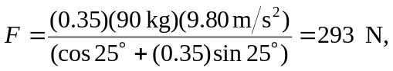
or 290 N to two figures.

